Solar Panel

Interface control Document (ICD)

Objective:

The goal of this document is to outline a set of requirements for the solar panels which control how they interface with the structure and electronics of the satellite. It will implement these requirements through a structural drawing and a PCB layout which can be referenced if/when a component that interfaces with a solar panel is redesigned. This document recognizes that the solar panels will be the most costly structural components to change once ordered, therefore this document is written with the goal of avoiding future changes, or at the very least, the solar panel will be last thing changed in future redesigns.

Center Panel (V1.3) Side Panel (V5.2)

CAD Rendering Eagle Schematic CAD Rendering Eagle Schematic

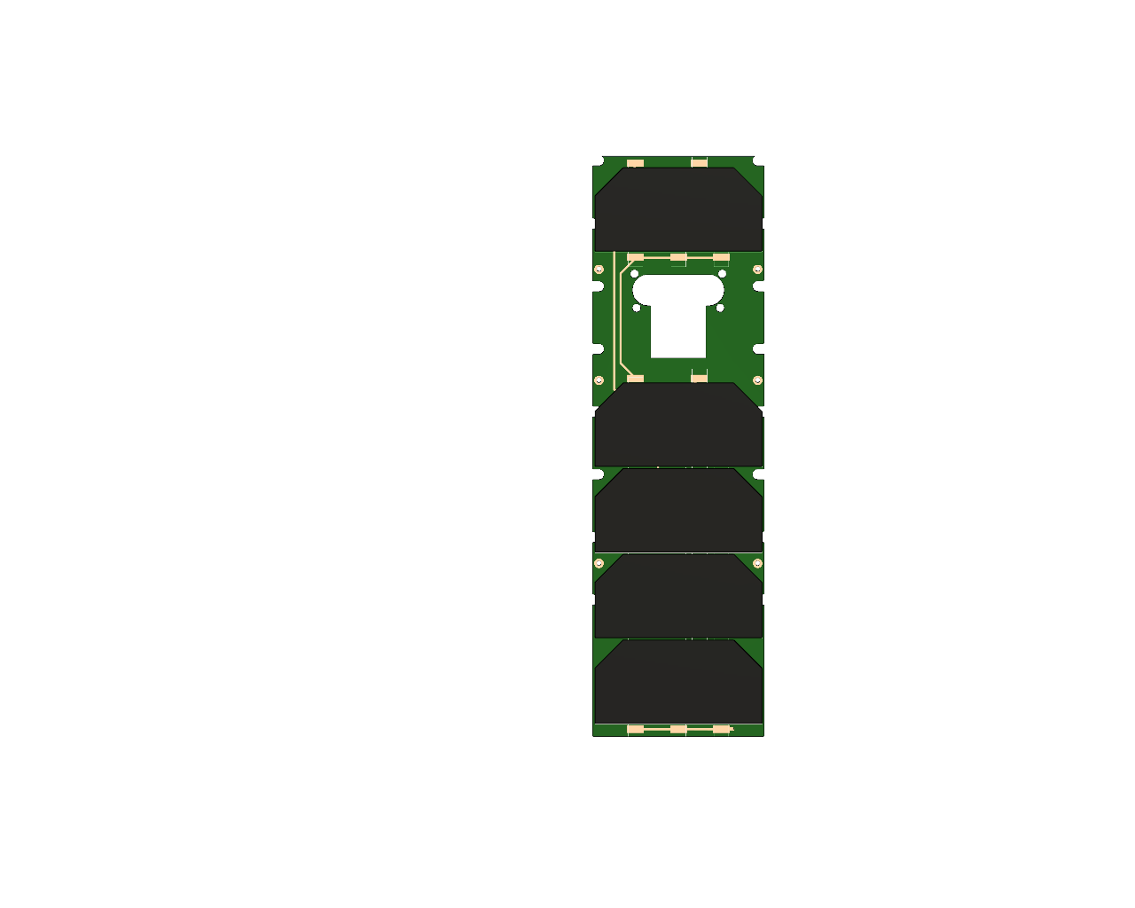 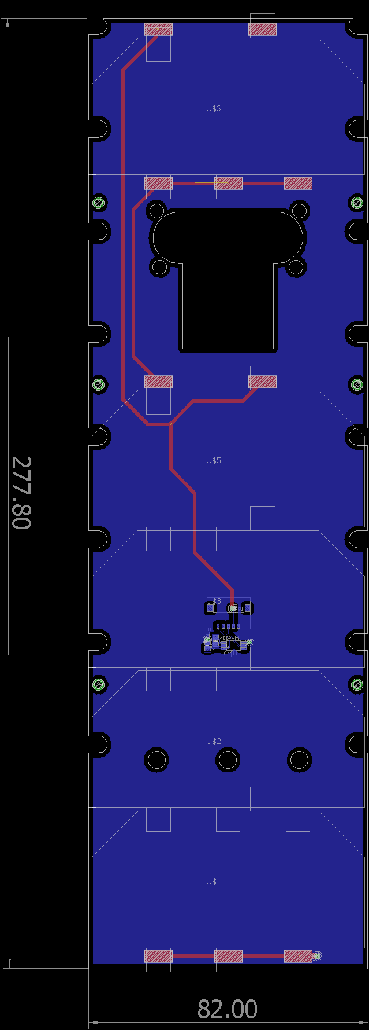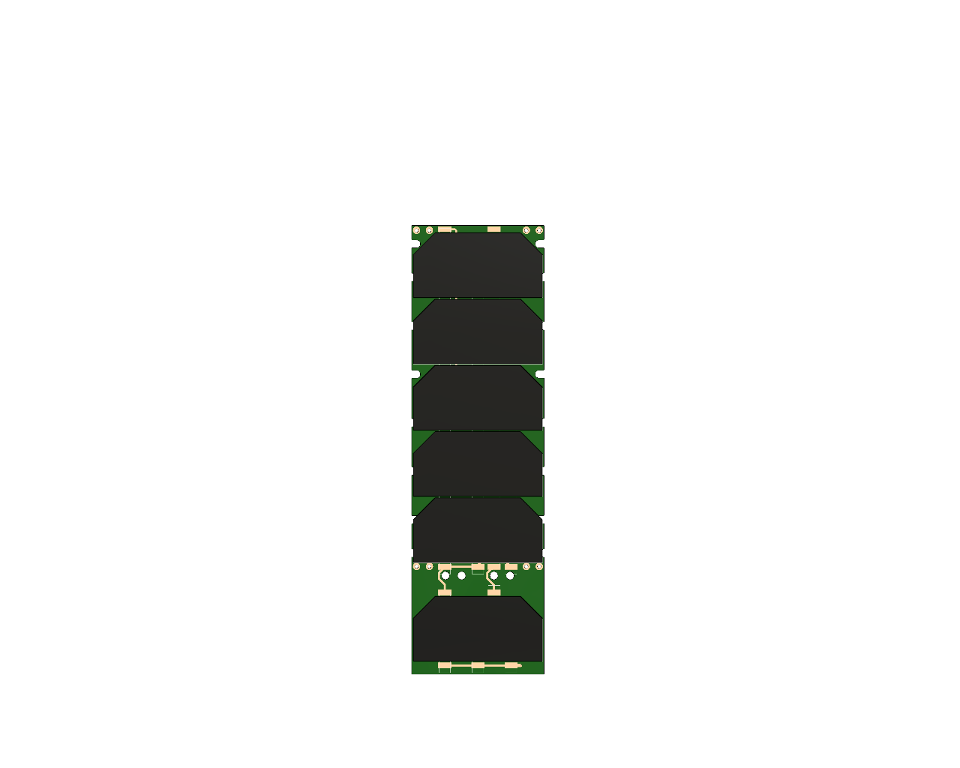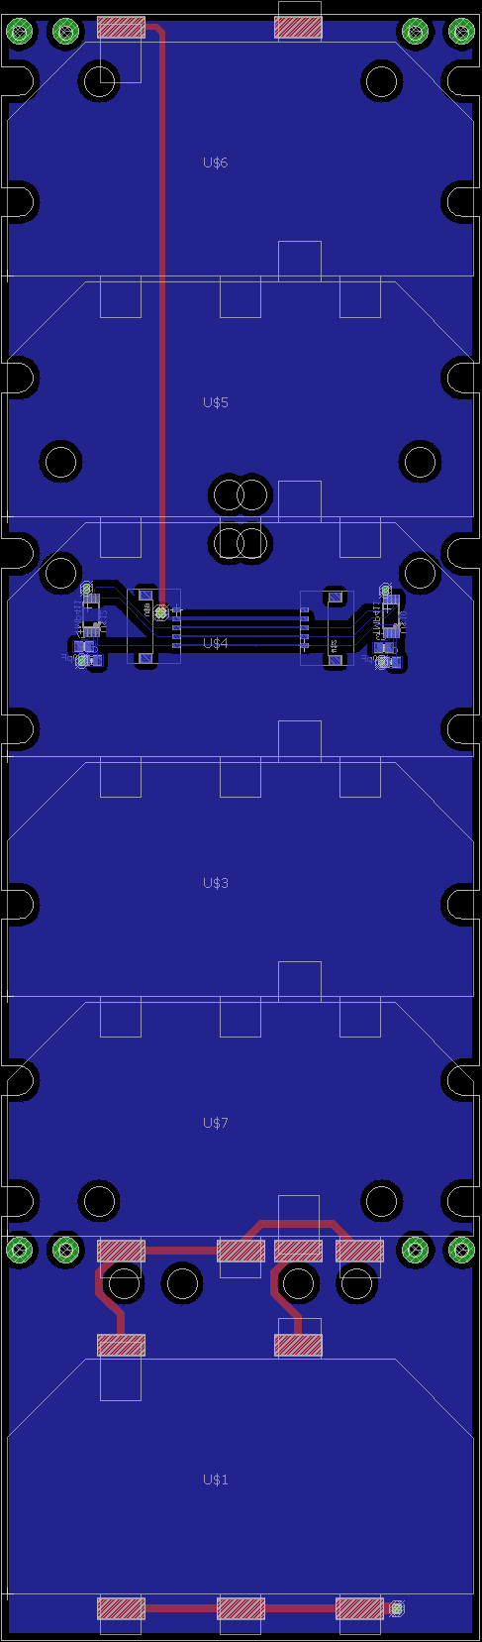

Size Limitations:

The size of the solar panels are limited by the shape of the deployment pod and the placement of deployable components.

* Width: 82mm

Board Cutouts:





















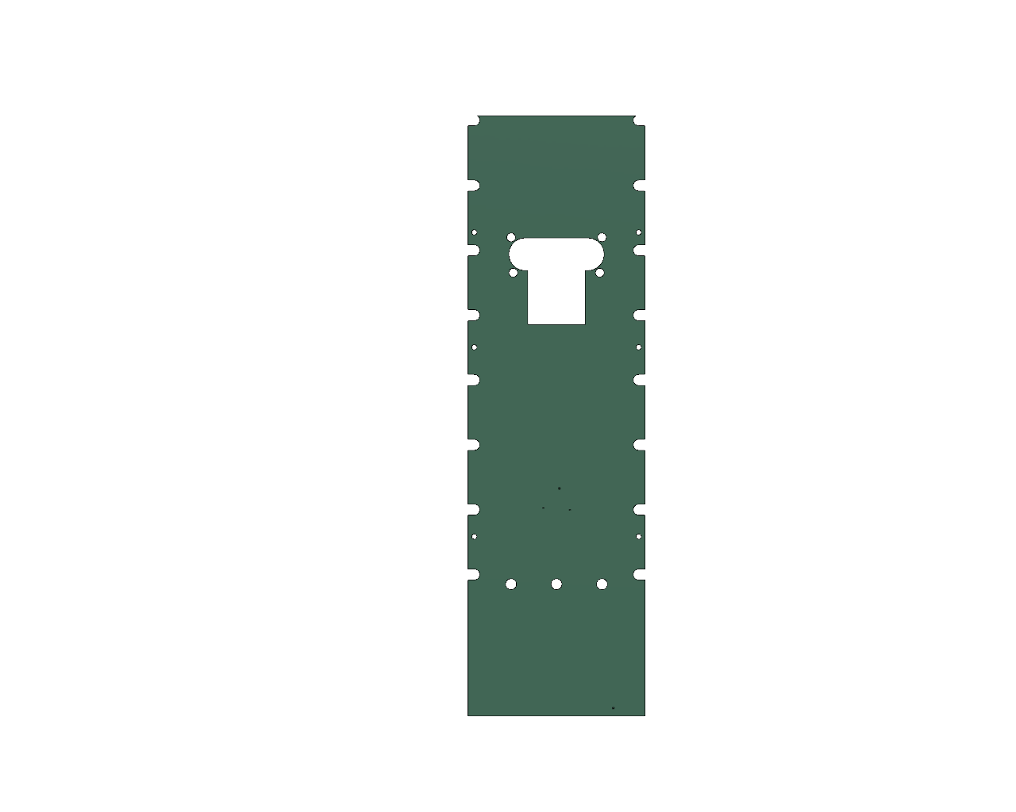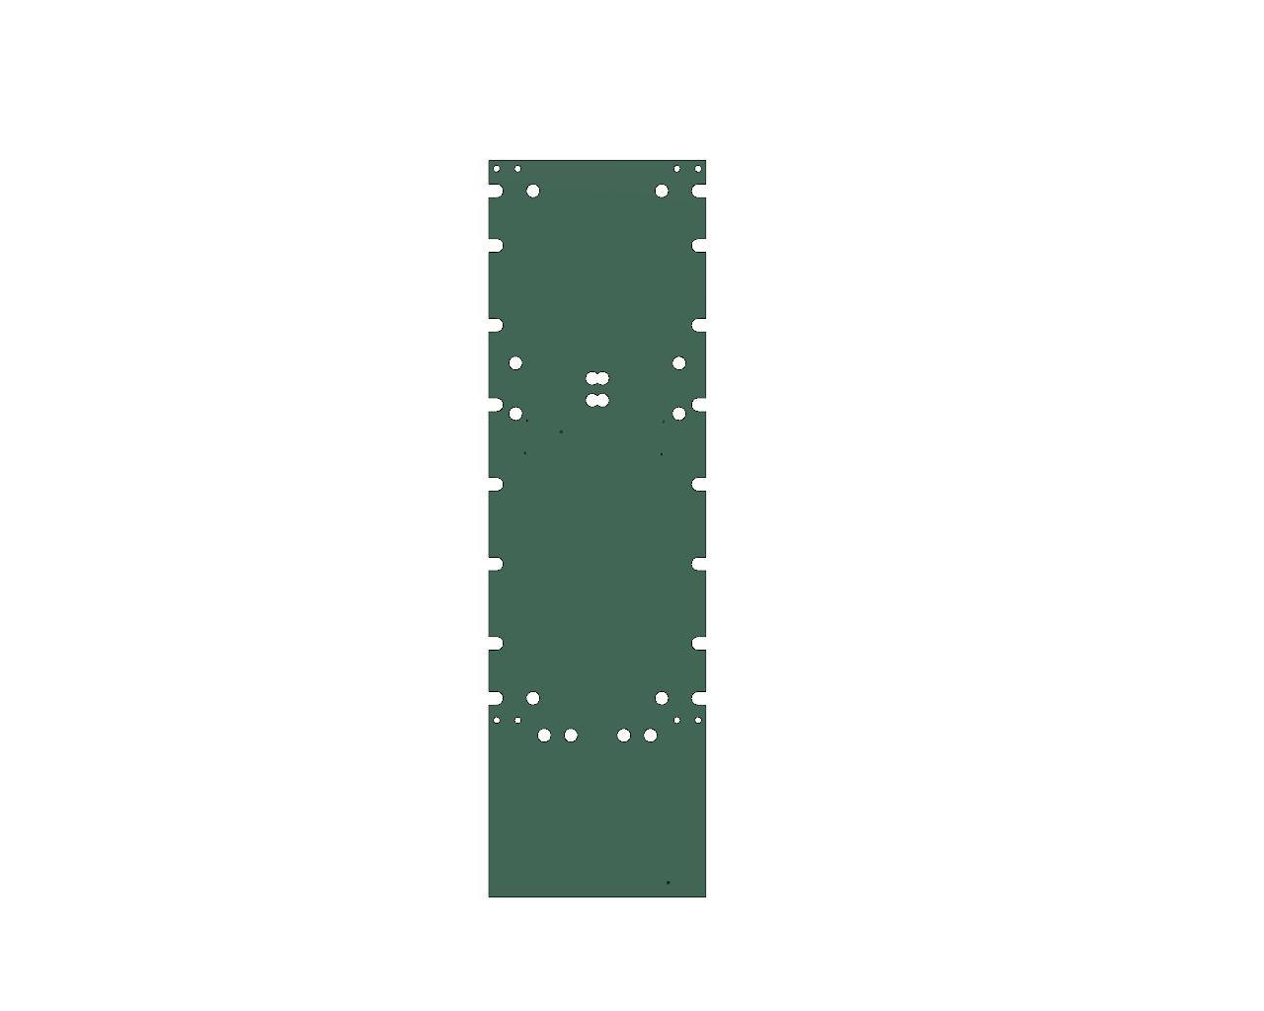

Interfacing components:

A: Chassis screws:

These cutouts are to accommodate the screws which mount the 1mm aluminum plate to the chassis. They are 2.5mm in diameter in order to fit around the 2-56 screw head. And the holes on the side are U shaped to avoid weak points close to the board edge.

B: Hinges

Insert info here.

C: Sun Sensor and GPS antenna module.

Insert info here.

D: Photodiodes

Sun Sensor/GPS antenna module

* + These two sun facing components are tied together on a mount which is attached to the underside of the chassis.
  + They extend through a cutout in the chassis and the center panel.
  + They have screws in the chassis which will create cutouts in the solar panel.

Hinge

* + There are two hinge plates on the top and bottom of the stack which are doubling as th